Minutes of the General Meeting of the Comstock Grizzlies
Saturday May 20th @ 2 pm
Dan and Tom’s Home – Carson City

General information and attendance:

Meeting called to order @ 3:13 pm by President Ken

Meeting Attendee’s: Nathan, Ken, Dan, Tom,
Dean, Thomas, Max, Jim, Jason, Larry, Jim

Attendee’s: 11

April 2023 minutes were sent to group.

Motion to approve as updated and reviewed.
Motion: Thomas Second Jason, Approved by acclimation.

Current information for these minutes.
Treasurers Report: Through 05/20/23

Previous Balance: $ 411.16
Transactions: IN $ 00.00

Transactions: OUT $ -00.00
Ending Balance: $ 411.16
Net Change: $ 00.00
No change from prior month

Motion to approve Treasury.
Thomas Second Jason, Approved by acclimation.

Reminder: Dues for Officers need to be paid by Feb. Meeting

Although dues are not required to attend activities.
We are all encouraged to renew your dues
and look at friends to become members.
Just so we have funds for our club expenses.

Web/Facebook Report:
Fully updated

Old Business:

Beer Bust will be Saturday June 17th @ 3pm-6pm.
$10 for members. $15 for guest. Free to new members for
$25 w/ free tee shirt. The club to provide hot dogs and chips.

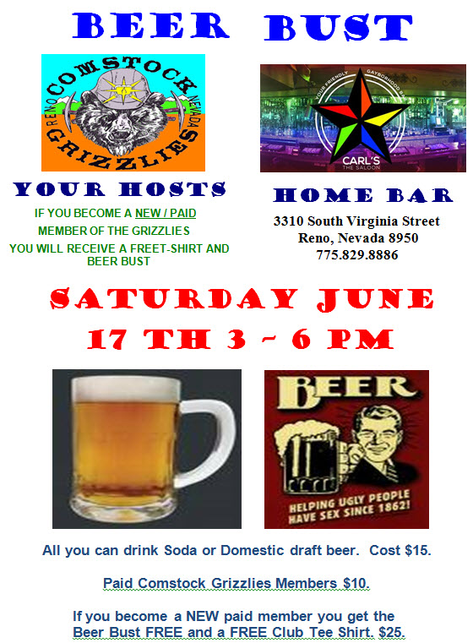

Motion to approve $100 to purchase food items and put toward
Beer cost for Beer Bust.
Motion: Thomas Second Jason, Approved by acclimation.

It was shared by Jason that Ron (Bear) of Carl’s Saloon
has passed away. There will be a Celebration of Life on April 23rd Sunday from 2-6 PM @ Carl’s Saloon. I’ll be posting notice on Web Site and Facebook.

Celebration of life was well attended. BEAR will be missed.

New Business:

I received a call from Marvel R. A founding but former member of the
Comstock Grizzlies. He wanted me to pass along to the group that he is back in the Northern Nevada area. He is living with family. He wanted to share he is in very poor health having suffered multiple
heart attacks and strokes. He appears to be house bound. If anyone would like to get in contact they can call him at: 505-313-3036.

Spring and Summer Activity Plans:

Thursday June 8th – 6pm-8pm $15
Nevada Museum of Art
Ghost army: The Combat Con Artist
Of World War II

We will meet in front at 6pm. Plan to eat before or after our visit.

Friday July 21st – 6pm - $15
Fleischmann Planetarium – UNR
Seasonal Stargazing

We will meet in front at 6pm. Plan to eat before or after our visit.

Aces Baseball Game

Looking at attending the game on Friday August 18th
Cost $20 - $30 depending on where we sit.

Other Activities Discusses but not scheduled:

Animal Arc Visit

Escape Room

Mini Golf

Movie Night

We will address these and other suggestions.

Dinner Night Out – Typically on a Tue, Wed or Thu
On 1st week of month.

Next Dinner Night Out planned:

Skipolini's
The Summit Reno
13971 S Virginia St, Reno, NV 89511

Thursday June 1st @ 6:30 pm
We plan to celebrate Dan’s Birthday

Next Meeting:

Carl’s Saloon – 3310 S. Virginia St. Reno
Saturday June 17th from 3-6 PM
Part of our Beer Bust
Meeting @ 6PM

Pot Luck Dinner and Club Meeting – Typically the 3rd
Saturday of the month

Hope to see you all there.

Close the meeting:
Motion: Thomas, Second Jason, Approved by acclimation.
Approved at 3:32 PM.

Respectfully Submitted
Nathan C. Secretary
May 28, 2023

